Order Form for
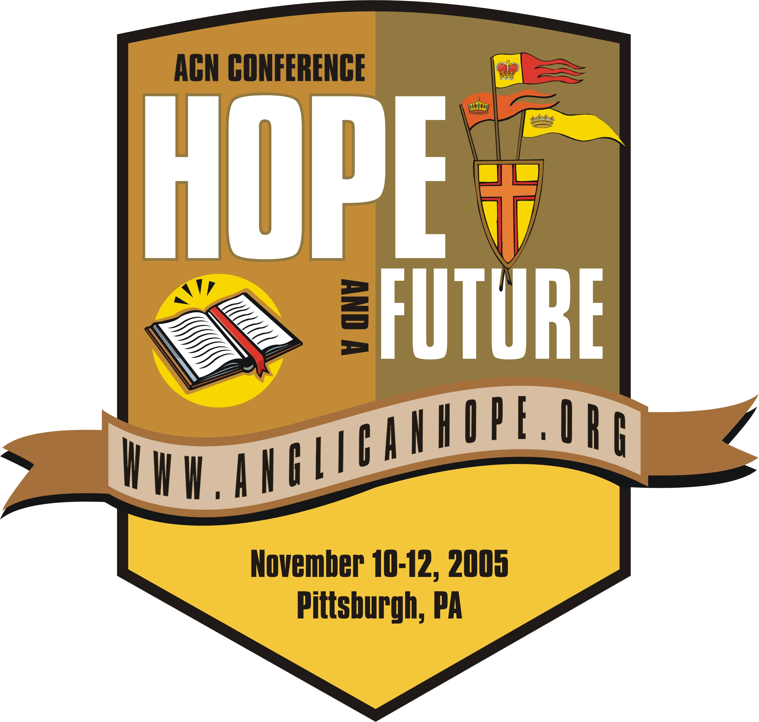

(1) “Choose This Day” DVD
(2) “The Message of the Hope & A Future Conference” DVD
(3) Individual Speaker CDs and DVDs from the Hope & A Future Conference

(1) “Choose This Day” DVD $5/each ______qty. x $5 = $_______
(2) “The Message of the Hope & A Future Conference” DVD $15/each ______qty. x $15 = $_______
(3) Individual Speakers of the Hope & A Future Conference:

Thursday, November 10th | CD $5 | DVD $15
Bible Teaching: The Rev. Dr. Kendall Harmon
Jesus Christ, The Hope of Uganda: The Most Rev. Henry Luke Orombi
Jesus Christ, The Hope of Nigeria: The Most Rev. Peter Jasper Akinola
Jesus Christ, The Hope of the Americas: The Rt. Rev. Keith L. Ackerman
Eucharist Sermon: The Rev. John A. M. Guernsey
Friday, November 11th
Bible Teaching: The Rt. Rev. Robinson Cavalcanti
Birthing the Network: The Rev. Canon David C. Anderson
Tribute to American Anglican Council & The Emergence of Common Cause:
Rev. Bill Atwood/The Most Rev. Leonard Riches
“What in the World is God Doing?” 8 minutes on Missions: Sharon Steinmiller
Global Anglicanism Realigning - Primates Panel: Global South Primates
The Rev. Dr. Rick Warren, Pastor
Valedictory from SE Asia, The Most Rev. Yong Ping Chung & Julia Chung
Anne Graham Lotz
Saturday, November 12th
Bible Teaching: The Rev. Dr. David Short
Baroness Caroline Cox
Joni Eareckson Tada
Sermon: The Rev. Canon Dr. Michael Green
Specials:
Bp. Duncan’s Opening Remarks and Summation
Total number of Conference Speaker CDs/DVDs
 | x $5.00 | x $15.00
Total amount for Conference Speakers CDs/DVDs | $ | $

TOTAL AMOUNT OF THIS ORDER…………………………………….……….….……$________

Shipping Information
Name/Church
Address
City/State/Zip
Phone/Email

Payment Method:
□Check: (Make check payable to: Anglican Communion Network)  Credit Card: □VISA □MasterCard
Card Number _________________________________________________________________
Expiration month/year _________________3-digit Security Code (on back of card)______________

Please mail this form to:
Anglican Communion Network
535 Smithfield Street* Suite 910 * Pittsburgh, PA 15222 * 412-325-8900 ph. * 412-325-8902 fax

